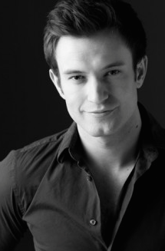
Mr. Matt Baker (B.F.A., Dance, 2008)
Matthew Baker is originally from Ann Arbor, Michigan. He earned his B.F.A. in Dance from Western Michigan University in April 2008. Baker has worked with KEIGWIN + COMPANY, Keith Thompson and Mark Dendy, just to name a few. In 2010, Baker assisted Larry Keigwin in choreographing New York’s largest fashion show in history, and began dancing for fellow K+C members Liz Riga and Rachel McKinstry’s Launch Movement Experience. Baker loves dancing and learning with the artists of K+C, and is looking forward to the discoveries still to come. He currently resides in New York City.
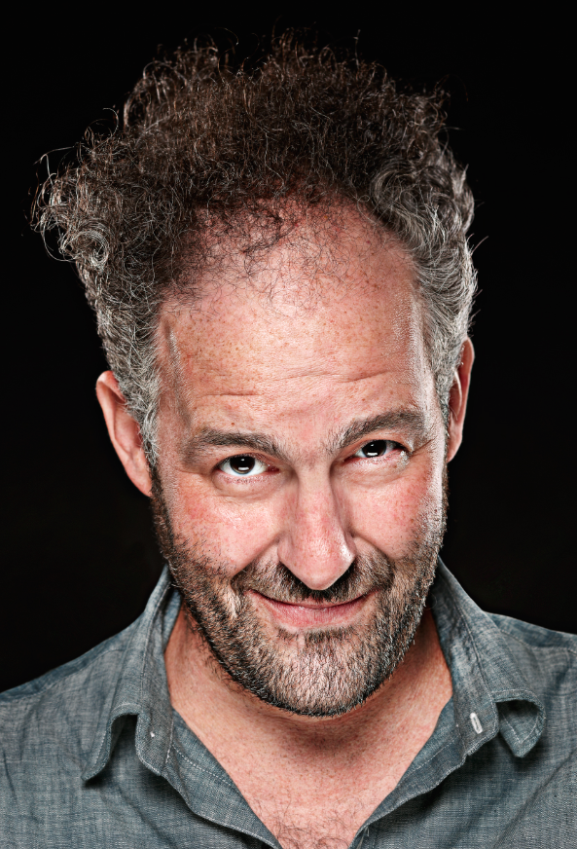
Mr. Wally Krantz (B.F.A., Art, 1993)
Wally Krantz grew up outside of Detroit, Michigan and received his B.F.A. in Graphic Design from Western Michigan University. He has earned numerous national and international design awards and has over 20 years of experience as a designer. Krantz currently serves as the worldwide creative director at Brand Union where he leads the design team in New York and oversees Brand Union’s 23-office network in the development of identities and visual identity systems.

Dr. Don Para (B.M., 1971; M.M., 1972)
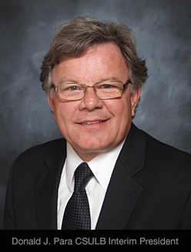
Dr. Donald J. Para earned a B.M in music education, and an M.M. in music composition from Western Michigan University. He received his Ph.D. in music composition from Michigan State University. Para was on the faculty at Western Michigan University and served as assistant director of the School of Music before serving as chair of the Department of Music at California State University, Los Angeles. At California State University Long Beach (CSULB), Para served as provost, senior vice president of academic affairs, associate dean, and dean of the College of Arts before retiring from his position as interim president in July 2014.

Mr. Dan J. Martin (B.A., MTP, 1976)
Dan J. Martin earned his B.A. in Music Theatre Performance at Western Michigan University (which inducted him into its Alumni Honors Society in 2002) and earned his Master of Fine Arts in Performing Arts Management at Brooklyn College/City University of New York under the tutelage of the late Stephen Langley, prominent arts management scholar and practitioner. Martin consults with cultural organizations in strategic planning, information technology, and finance management. He also serves on the faculty of the Management and Development of Cultural and Artistic Organizations Program at the University of Bologna (Italy), and serves on the advisory board of the Fitzcarraldo Foundation, an arts management training and consulting center in Turin, Italy. Martin currently serves as Dean of Carnegie Mellon University’s College of Fine Arts.

