WMUx Summer Series 2022 on Inclusive Teaching
Action & Expression: Assignments, Rubrics
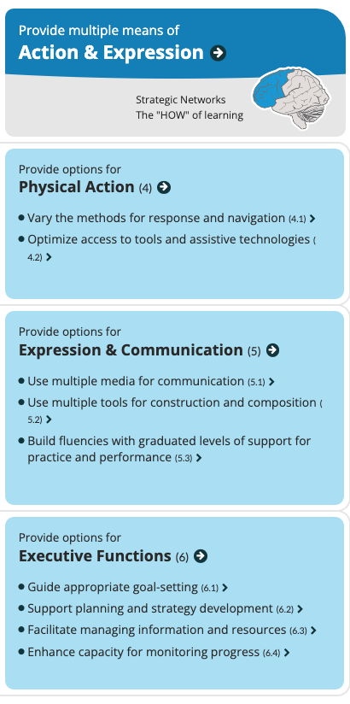
UDL Framework on Action and Expression: https://udlguidelines.cast.org

Grading & Rubrics Matrix

J. Stommel: "How does it feel to grade? How does it feel to be graded?"​
Grading ≠ Feedback and Learning​
Focus Questions​
You​ | How do you feel about grading? What do grades mean to you? What do you expect your students to feel about grading? Get clear on your emotional investments here so that you can make conscious and rational decisions about how to help students learn (which is different from grading!).
Assess Skills​ | Are your assignments clearly linked to figuring out if students know how to do the things you want them to do? How are you converting information into usable knowledge?​
Scaffold​ | Do assignments permit a focus on individual skills? If there are multiple skills, consider breaking up the assignment into separate parts. Consider resubmission to guide improvement.​
Simplify ​ | Are assignment prompts comprehensible? Are you spending a lot of time justifying your evaluations without the possibility that students could re-do? Develop rubrics (criteria/descriptors/performance levels) to simplify scoring. Consider on/off criteria with unlimited resub. In any case, get clear on what is important and lose the distractions.​
Student​Involvement​ | Have you opened the evaluation and feedback process to students? Do they know how you grade or evaluate them? Can they participate in the process? Do they help you create rubrics, or evaluate themselves, or each other? ​
Design Process​  ​ | Adopt a "backward design" philosophy to ensure you are making conscious choices about how you design and evaluate assignments, and all student work in the course. ​

