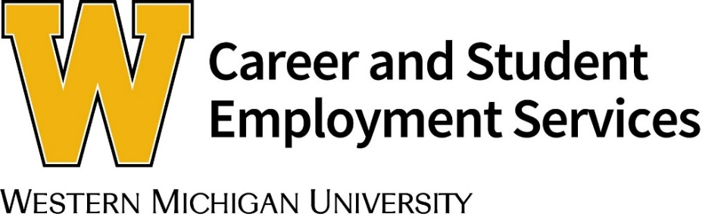
wmich.edu/career/employers | career-recruiting@wmich.edu | (269) 387-2745
Remote Employer Sessions
Employers may host a remote session for students using a virtual platform of their choice. To host a session, please follow these steps:

- Decide what type of student session you would like to host (see list below for details).
- Select a session date and time.
- Once a session is set up, send the session title, description, registration links and passwords, to the Employer Engagement Team.
- Share what student majors the content of the session is designed for, or whether the content is for all student majors. The Employer Engagement Team will enter the session into Handshake for students to view, and can help promote it to appropriate majors.
- Recording any of the session types below is encouraged to allow students who were not able to attend, to view it at another time. If you record your session, please send it to us via email.

Contact the Career and Student Employment Services Employer Engagement Team to schedule a remote session at career-recruiting@wmich.edu or (269) 387-2745.

Types of Remote Session Programming

Information Spotlight Session (15 to 30 minutes)
An information spotlight highlights your company culture, application process, and what you seek in candidates for opportunities you are hiring for.

Student Education Session (15 to 60 minutes)
Career and Student Employment Services appreciates an employer’s expertise and knowledge. Possible student education sessions to host include: virtual job fair preparation (actions to take before, during and after the fair), how to network with employers during COVID-19, remote workplace etiquette best practices, communication tips when working remotely, or other approved topic that would be beneficial to help students.

Employer Video (1 to 3 minutes)
Submit a short video that highlights your company or organization. The Employer Engagement Team can assist with promotion of the video to students.

Resume Review
Participate in a career services resume review session prior to job fair or networking event. A career services resume rubric is given to each representative to use for evaluating each resume.

Practice Interview
Help students practice their interview skills by hosting a half-day session prior to a job fair or networking event. Instruction will be given on how to create an interview schedule, and a career services practice interview rubric will be provided for evaluating each interview.

Remote Work: Setting Best Practices

Examine the job description for the position and brainstorm how each function of the position’s workflow could be performed remotely. Ask the following questions:

- What equipment, software, internet/hot spot, and other office resources does the role require to be performed in a remote setting?

- Set new, realistic, expectations for the role with the supervisor and high-contact team members. Place the goals and objectives in writing and provide detailed instruction on how work will be performed. Include a staff communication plan outlining expectations regarding remote communication among team members.

- Create an onboarding document outlining the job expectations and how the remote employee is to perform their work. Include items such as: their work schedule (days of the week and start/end time); how, when and where work should be submitted; who they contact to ask questions or report issues; expected meeting dates/times to attend; how to submit payroll hours, and how to purchase or request reimbursement for approved purchases for tasks or projects.

- If you examine a position and find that the job can't be performed remotely, but you still want to hire a student for an internship, examine your organization's wish list of projects that could be performed remotely. Determine if a student could handle the project, or assist with part of it. This could help to free up time in another staff member’s position so they can focus on another task, or complete a project sooner.

- If feasible, have a student intern help brainstorm what tasks or projects they feel could be performed virtually, and how the work could be completed. Interns often see opportunities that more seasoned staff may not consider.

Best Practices for Remote Work Articles

http://info.parkerdewey.com/remote-internships-101

https://ocs.yale.edu/narrative/tips-guidelines-employers-create

https://www.naceweb.org/talent-acquisition/internships/duolingo-takes-strategic-innovative-steps-in-virtual-internship-program/

https://www.naceweb.org/diversity-equity-and-inclusion/best-practices/providing-support-to-onlies-in-the-workplace-and-remotely/

https://www.naceweb.org/talent-acquisition/internships/communication-with-interns-critical-during-uncertain-times/

https://www.naceweb.org/talent-acquisition/internships/asurion-adding-additional-training-networking-opportunities-for-virtual-interns/

https://www.naceweb.org/talent-acquisition/best-practices/best-practices-for-supporting-students-remotely/

https://www.naceweb.org/talent-acquisition/internships/communication-connection-keys-for-high-quality-remote-internships/

https://www.naceweb.org/talent-acquisition/best-practices/top-perks-for-interns-can-be-adapted-for-virtual-workplace/

If you have remote workplace best practices to share, we would like to learn about them. Please contact the Employer Engagement Team at career-recruiting@wmich.edu. Thank you!

