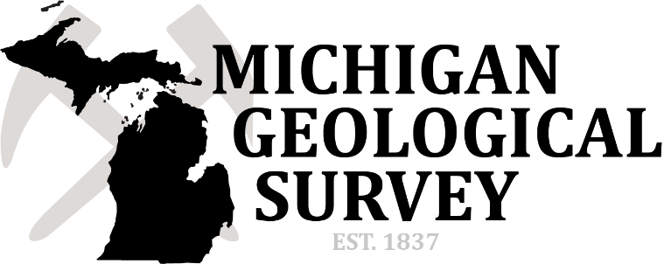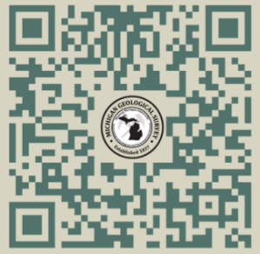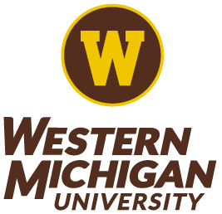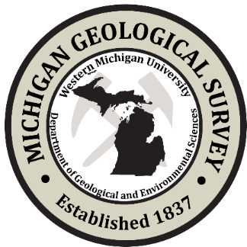

*Join Our Team!*

***Department of Geological and Environmental Sciences, College of Arts and Sciences***

***Seeks Candidates for Director of Michigan Geological Survey***

Operation of the Michigan Geological Survey (MGS) was transferred to Western Michigan University’s (WMU’s) Department of Geological and Environmental Sciences in 2011 ([**http://www.geology.wmich.edu/**](http://www.geology.wmich.edu/)). In January 2023, MGS was granted annual funding as part of the state budget to support the societal needs of Michigan. Under this funding, MGS has grown rapidly over the past year, adding new staff and projects related to geologic mapping, critical minerals, groundwater resources and usage, near surface resources, and natural hazards. The MGS Director will oversee all functions of the Survey to accomplish and maintain current mapping and research programs, and to support the expansion of mapping and research to assess Michigan’s natural geologic resources, as mandated by the Michigan State Geologist and Department of Energy, Great Lakes, and Environment and the Governor’s office.

Applicants should submit on-line a cover letter, curriculum vitae using the following website: **https://www.wmujobs.org/postings/1637** and names and contact information for three references. Inquiries should be addressed to WMU HR, Review of applications will begin October 1 and continue until position is filled. Western Michigan University is an affirmative action/equal opportunity employer consistent with applicable federal and state law.

**Preferred qualifications:**

* Ten years relevant experience, including experience working with geological surveys and/or state legislative units,
* PhD with a research focus on geologic mapping, energy, critical minerals, hydrogeology, or glacial geology; and
* Professional geologist licensure.

**Minimum qualifications**

* Master’s degree in geosciences or closely related field,
* Minimum of 5 years relevant experience in industry, academia or a state geological survey that includes fundraising, securing grants and/or contracts, preparing professional reports and publications, and managing staff; and
* Strong oral and written communication skills, and experience with public outreach or communication.

**Responsibilities of the Director include**:

1. Providing coordination, oversight, and administration of the overall activities of MGS in consultation with the Chair of the WMU Geological & Environmental Sciences Department, the State Geologist of Michigan, the MGS Advisory Council, and the WMU Government Relations office;
2. Supervising the activities of operational units within the MGS including mapping, surface and subsurface geology, energy and mineral resources, geologic hazards, research, education, outreach, and water resources;
3. Developing strategic long-term plans for the MGS,
4. Developing new programs and funding initiatives to support the State of Michigan stakeholders,
5. Developing and implementing budgetary plans to support MGS activities,
6. Writing or guiding annual proposals for STATEMAP and Great Lakes Mapping Coalition grants, and producing maps meeting standards of the U.S. Geological Survey.
7. Writing research proposals and reports to funding entities that will benefit Michigan and student training and research, publishing research findings, and presenting at local, regional, national and international venues,
8. Attending relevant local and national meetings for state geological survey directors,
9. Conducting outreach and giving public presentations of MGS projects and results, and
10. Acting as a liaison between MGS and relevant regional, state and national organizations, committees and programs with interests in MGS related research, repository or outreach initiatives.

**Western Michigan University** is a vibrant, nationally recognized student-centered research institution with an enrollment of around 18,000. WMU delivers high-quality undergraduate instruction, has a strong graduate College, and fosters significant research activities. The Carnegie Foundation for the Advancement of Teaching has placed WMU among the 76 public institutions in the nation designated as research universities with high research activities.

* ***INSIGHT into Diversity*** consistently honors WMU for its outstanding commitment to diversity and inclusion.
* ***Military Times*** ranks WMU among the best institutions for veterans, and WMU is the only Michigan school to appear on all nine years of its annual Best for Vets list.
* **U.S. Department of State** data shows that WMU was No. 6 among producers of American Fulbright Scholars in 2016-17.
* **WMU** operates the nation’s largest and most comprehensive collegiate support program for former foster-care youth and is an international model for teaching, research, learning, and public service related to foster care and higher education.
* ***Washington Monthly*** ranked WMU first in the state of Michigan on its impact on alumni earnings 10 years after graduation.

**Kalamazoo, MI:** Kalamazoo is a diverse community, located only two and a half hours by car from Chicago and Detroit and only 45 minutes from the beaches of Lake Michigan. It is in one of Michigan’s designated research corridors, maintaining a strong life sciences/biotech presence and supporting two leading medical centers. With 263,000 people in the greater Kalamazoo area, the community offers an array of cultural events, entertainment, and all-season recreation. The city supports a nationally recognized symphony and has earned a reputation for a vibrant community theatre and visual arts scene. Kalamazoo is committed to social justice, community development and the elimination of generational poverty through its Shared Prosperity Kalamazoo initiative, with structural budgetary support provided by the City of Kalamazoo’s Foundation for Excellence program. Kalamazoo also is the home of the Kalamazoo Promise, a scholarship program offered to all Kalamazoo Public School students that covers up to 100% of tuition and mandatory fees to any Michigan public (and many private) institution of higher learning.

**Salary:** Competitive and commensurate with qualifications and experience, with an excellent benefits package.



Applicants should submit on-line a cover letter, curriculum vitae using the following website: [**http://www.wmich.edu/hr/careers-at-wmu.html**](http://www.wmich.edu/hr/careers-at-wmu.html)and names and contact information for three references. Inquiries should be addressed to WMU HR, Review of applications will begin October 1 and continue until position is filled. Western Michigan University is an affirmative action/equal opportunity employer consistent with applicable federal and state law.